
Software and Database Project

Projract Title : Official Document Archiving Management System
Name : Maryam Ahmed and Zainab Moayad
Satge : Third
Al – Nahrain university
College of science department of computer science
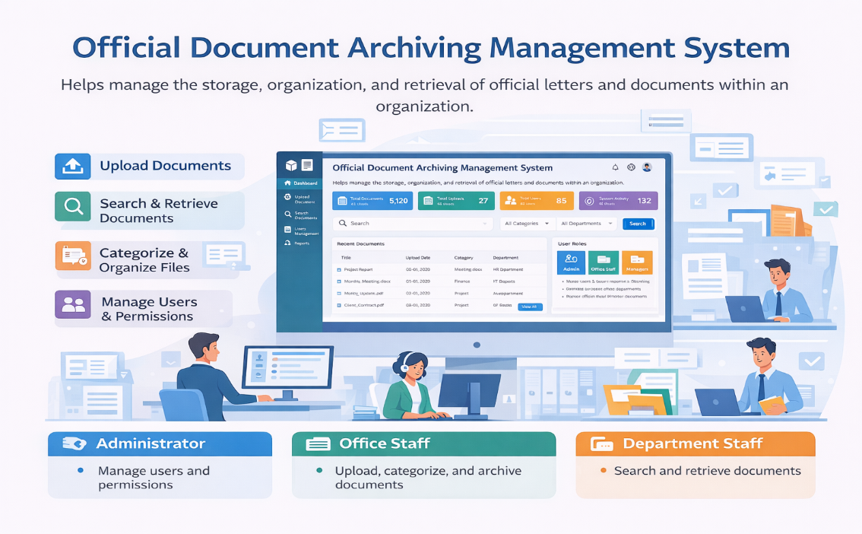

Introduction
Organizations deal with many official letters and documents every day. Managing these documents using paper files or random digital folders can cause many problems such as losing documents or difficulty finding them.
The Official Document Archiving Management System is designed to help organizations store, organize, and manage official documents in a digital way. The system will make it easier for users to upload, search, and retrieve documents quickly and safely.

System Interface Overview
The system interface is designed to be simple and easy to use.
Users log in to the system and access the features according to their role in the organization.
The main interface includes:
- Login Page
- Dashboard
- Document Upload Page
- Document Search Page
- Document Management Page
- Reports Page
- User Management Page
Each user sees different options depending on their permissions.

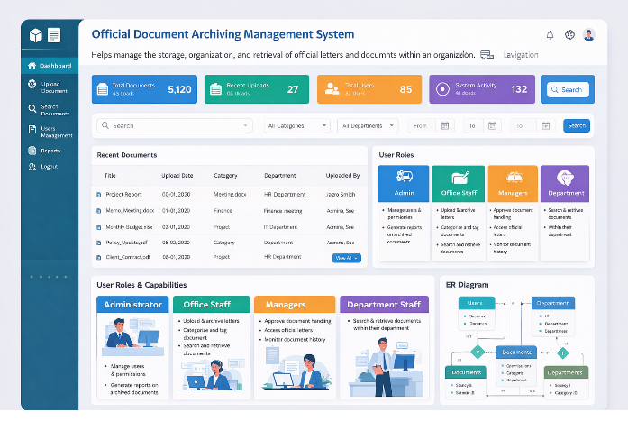

User Roles in the System
The system has four main types of users.

3.1 Administrator Interface
The Administrator has full control over the system.
Administrator interface allows the user to:
- Manage users (add, delete, update users)
- Assign permissions to users
- View system information
- Generate reports about archived documents
The administrator dashboard shows:
- Total number of documents
- Number of users
- Activity reports

3.2 Office Staff (Secretaries) Interface
Office staff are responsible for handling and archiving documents.
Their interface allows them to:
- Upload new official letters
- Archive documents in the system
- Categorize documents
- Add tags to documents
- Search for archived documents
- Retrieve documents when needed
This interface focuses on document organization and storage.

3.3 Managers / Department Heads Interface
Managers use the system mainly for monitoring and approval.
Their interface allows them to:
- Access official letters for reference
- Approve document handling processes
- Monitor document history
- View document details
Managers can track how documents move within the organization.

3.4 Department Staff Interface
Department staff have limited access compared to other users.
They can:
- Search for documents
- Retrieve documents within their department only
This helps maintain document security and privacy.

System Benefits
The system provides several benefits:
- Easy document storage
- Fast document searching
- Better organization of official files
- Secure access control
- Monitoring of document history
It reduces the use of paper documents and improves efficiency in the organization.

System Use Case Explanation
The system allows different users to perform different actions depending on their roles.
Main Use Cases
1. Login to the System
- All users must log in using their username and password.
- The system checks the user role and gives the correct permissions.
2. Upload Document
- Office staff upload new official letters.
- They add information such as:
  - Document title
  - Date
  - Department
  - Category
  - Tags
3. Archive Document
- After uploading, the document is stored in the database.
- The system saves all document information for future access.
4. Search for Document
- Users can search documents using:
  - Title
  - Category
  - Department
  - Date
5. Retrieve Document
- Authorized users can open or download archived documents.
6. Manage Users
- The administrator can:
  - Add users
  - Delete users
  - Edit user information
  - Assign roles
7. Generate Reports
- The administrator can generate reports about:
  - Number of archived documents
  - Document categories
  - System activity

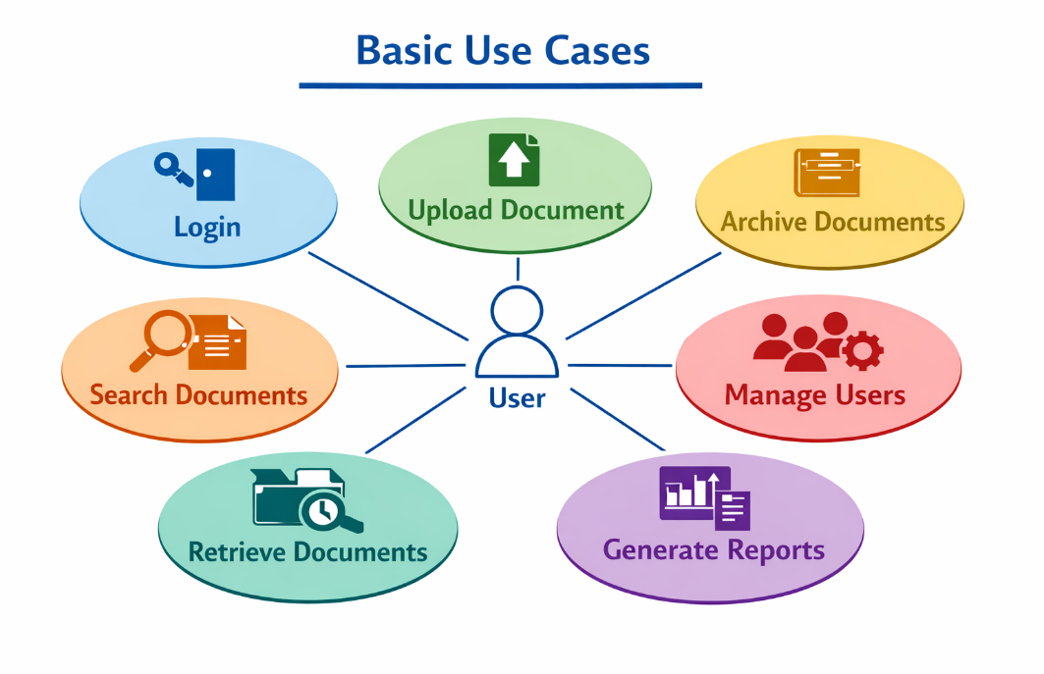

Database Design Overview
The system database is designed to store and manage all document information.
The database contains several main tables.
1. Users Table
This table stores information about system users.
Example fields:
- User_ID
- Username
- Password
- Role
- Department

2. Documents Table
This table stores the main information about documents.
Example fields:
- Document_ID
- Title
- Upload_Date
- Category_ID
- Department_ID
- Uploaded_By

3. Categories Table
This table stores document categories.
Example fields:
- Category_ID
- Category_Name
Example categories:
- Official Letters
- Reports
- Internal Documents

4. Departments Table
This table stores organization departments.
Example fields:
- Department_ID
- Department_Name
Example:
- HR Department
- Finance Department
- IT Department

5. Document_History Table
This table stores document actions.
Example fields:
- History_ID
- Document_ID
- Action
- Action_Date
- User_ID
This helps managers monitor document history.

System Interface Pages
1. Login Page
The login page allows users to enter:
- Username
- Password
After login, the system redirects the user to the dashboard.

2. Dashboard
The dashboard shows general information such as:
- Total documents
- Recent uploads
- System notifications

3. Upload Document Page
This page allows office staff to:
- Upload a document file
- Enter document information
- Select category
- Add tags

4. Document Search Page
Users can search documents using filters like:
- Title
- Department
- Category
- Date

5. User Management Page
This page is only available for the administrator.
It allows:
- Adding users
- Editing users
- Removing users
- Assigning roles
The ER Diagram shows the structure of the database and the relationships between different entities in the system.
The system contains several main entities:

1. Users Entity
This entity stores information about all users in the system.
Attributes:
- User_ID (Primary Key)
- Username
- Password
- Role
- Department_ID
Each user has a specific role such as:
- Administrator
- Office Staff
- Manager
- Department Staff

2. Documents Entity
This entity stores information about all archived documents.
Attributes:
- Document_ID (Primary Key)
- Title
- Upload_Date
- Category_ID
- Department_ID
- Uploaded_By
Each document is uploaded by a user.

3. Categories Entity
This entity stores the categories of documents.
Attributes:
- Category_ID (Primary Key)
- Category_Name
Examples:
- Official Letters
- Reports
- Internal Documents
Each category can contain many documents.

4. Departments Entity
This entity stores information about organization departments.
Attributes:
- Department_ID (Primary Key)
- Department_Name
Each department can have many users and many documents.

5. Document History Entity
This entity records actions performed on documents.
Attributes:
- History_ID (Primary Key)
- Document_ID
- User_ID
- Action
- Action_Date
This helps managers monitor document activity.

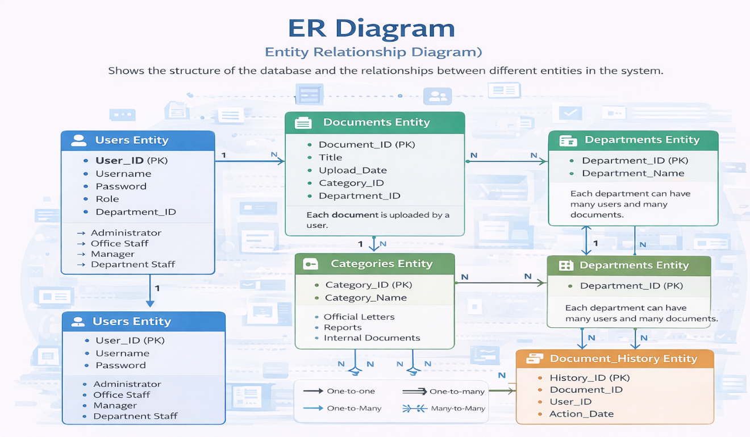

Relationships Between Entities
- User → Documents
- One user can upload many documents.
- Relationship: One-to-Many
- Category → Documents
- One category can contain many documents.
- Relationship: One-to-Many
- Department → Users
- One department can have many users.
- Relationship: One-to-Many
- Department → Documents
- One department can have many documents.
- Relationship: One-to-Many
- Documents → Document History
- One document can have many history records.
- Relationship: One-to-Many

Conclusion
The Official Document Archiving Management System is designed to help organizations manage their official documents in a simple and organizedway.The system allows users to upload, archive, search, and retrieve documents easily.
It also provides security through role-based access control, ensuring thateach user can only access the documents allowed for their role.This system improves efficiency, organization, and document security in the workplace.
